Ideation Phase
Brainstorming and Prioritization

Date | 30 September 2026
Team ID | SWTID-2026-7764
Project Name | Import Data using Transform Maps (Spreadsheet)
Maximum Marks | 4 Marks

Use the project walkthrough to prioritize clean imports, duplicate prevention, clear run history, and useful reports.
This working session organizes ideas around the project’s actual workflow: prepare the workbook, create the target and staging tables, transform and validate records, then report and share results.
Prioritize prerequisites first. Confirm the five-field schema, create Employee Test and Employee Import, map the fields, set Employee ID coalesce, and finish with reports and dashboard sharing.
Project source: Import Data using Transform Maps project walkthrough and dashboard snapshot.
Step 1: Confirm the five employee fields, source workbook headers, and Employee ID as the coalesce key.
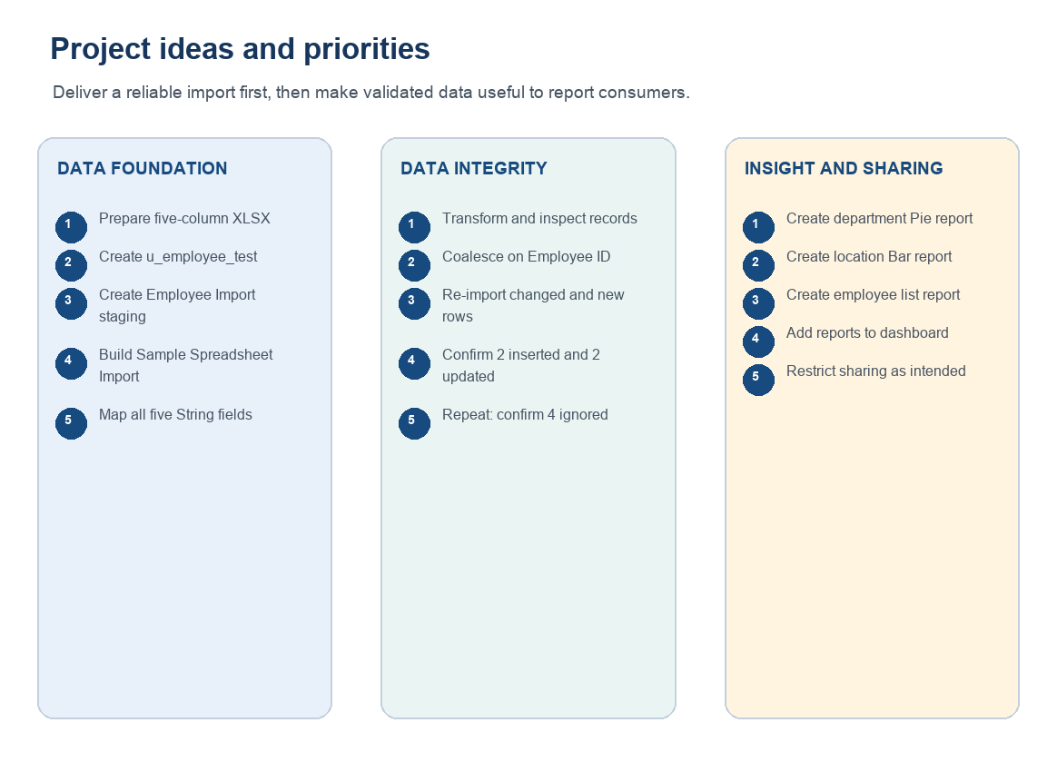

Step 2: Group work into spreadsheet/table setup, Import Set and Transform Map, validation/coalesce and dashboard sharing controls, and reports/dashboard.
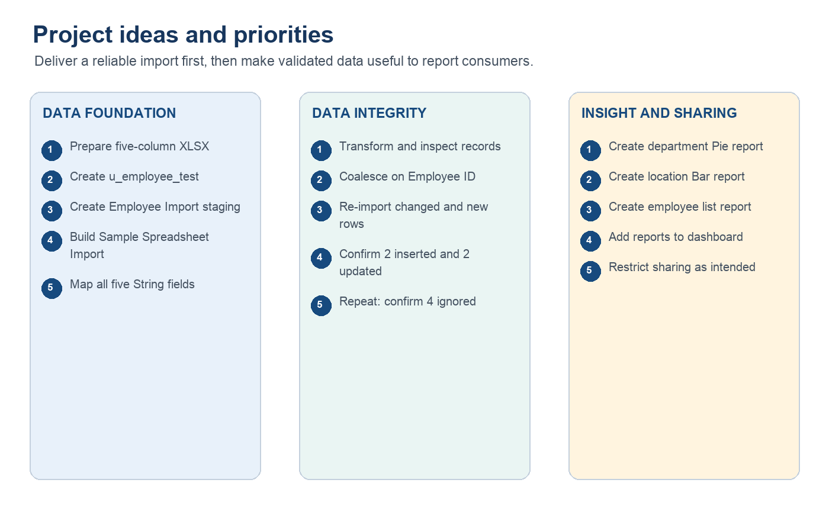

Step 3: Prioritize valid imports and no unintended duplicates first; then verify Department, authorized project user access, and actionable reports.

